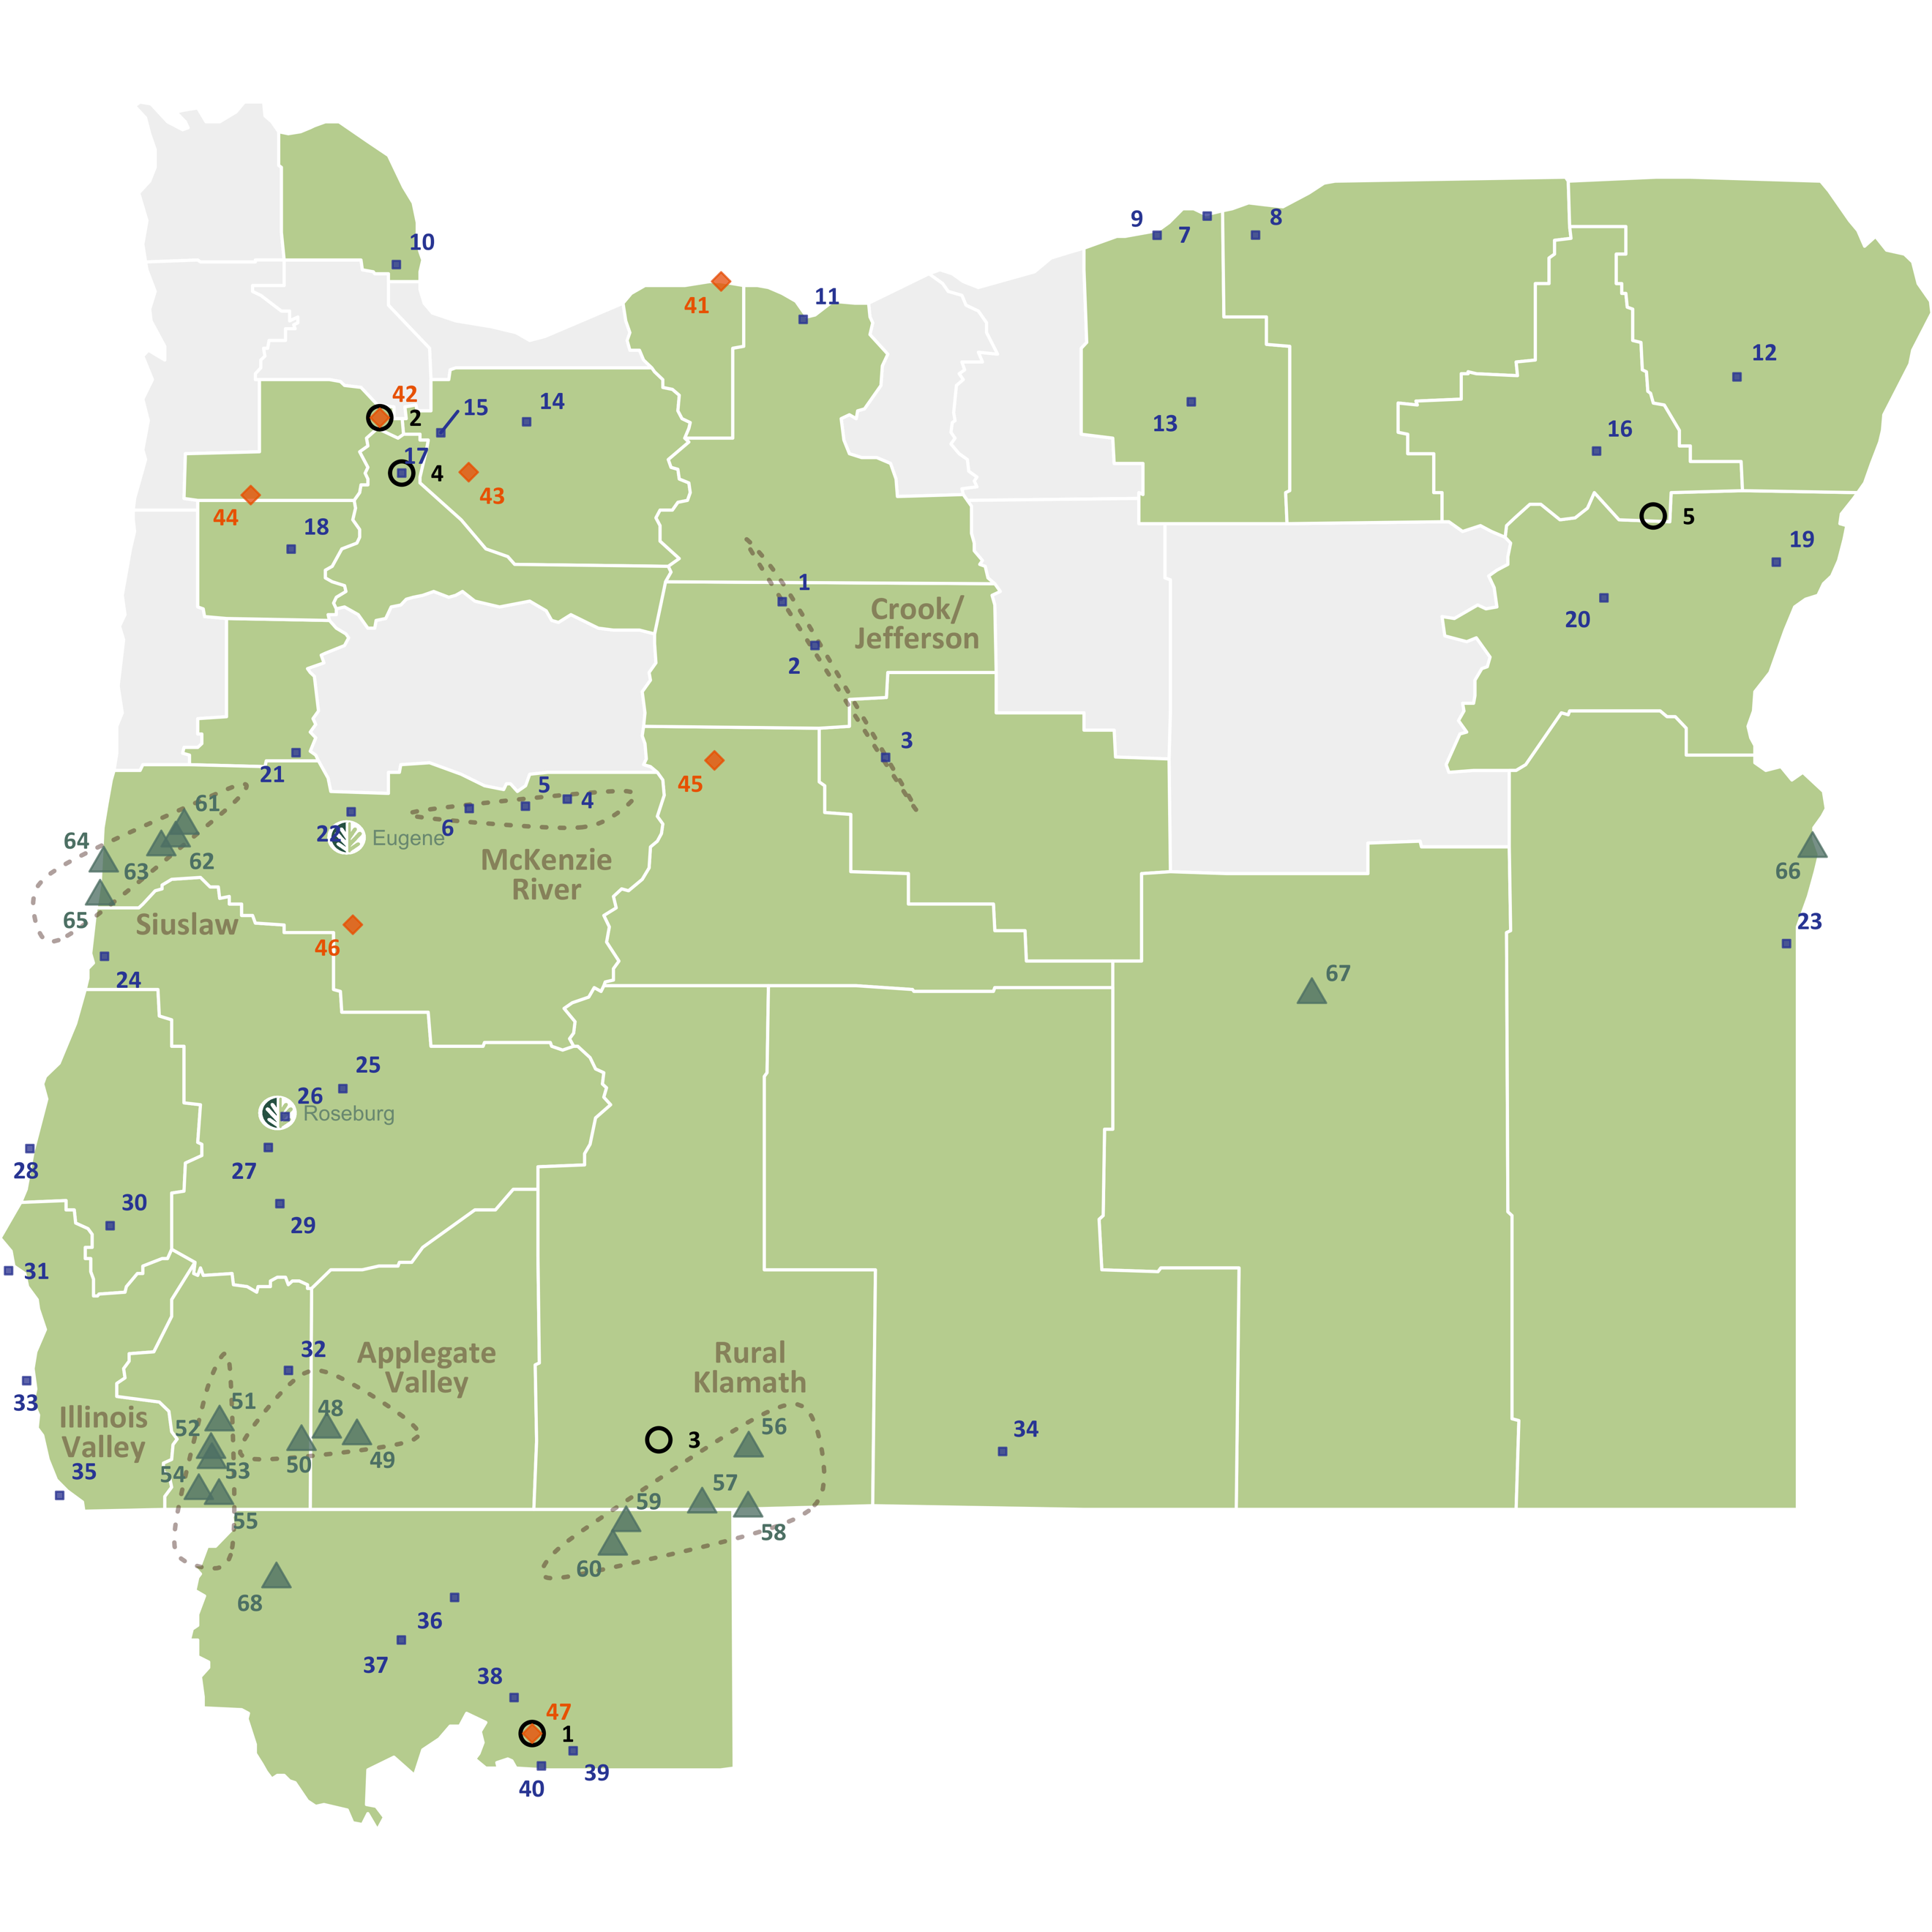

|  |  |  |  |  |  |  |  |  |  |  |  |  |  |  |
| --- | --- | --- | --- | --- | --- | --- | --- | --- | --- | --- | --- | --- | --- | --- |
| FICB work present in county  Work coordinated across multiple communities  **⭘ Field Coordinators ­**  1. Crystal Aston (Mt Shasta) 2. Denise Bacon (Newberg) 3. Katie Jameson (Klamath Falls)  4. Laura Isiodria (Woodburn) 5. Maurizio Valerio (Medical Springs)  **Types of Work – 4Cs**   |  |  |  |  | | --- | --- | --- | --- | | **Connections**  Community Networking  Listening | **Capacity**  Latino Leadership  Local Mobilizing  Regional Mobilizing | **Community-Led Action**  Project Development | **Culture**  Visioning | | **FICB Work Map**  **◼ Developing**  Communities are interested in CBA, with work, relationships, roles and CBA alignment coming into focus.   |  |  |  | | --- | --- | --- | | ***Crook/Jefferson***  1. Warm Springs  2. Madras  3. Prineville  ***McKenzie River***  4. McKenzie Bridge  5. Blue River  6. Vida  7. Irrigon  8. Hermiston  9. Boardman  10. Scappoose  11. The Dalles | 12. Enterprise  13. Heppner  14. Estacada  15. Canby  16. Union  17. Woodburn  18. Dallas  19. Halfway  20. Baker City  21. Monroe  22. Coburg  23. Adrian  24. Reedsport  25. Glide | 26. Roseburg  27. Winston  28. Bandon  29. Riddle  30. Powers  31. Port Orford  32. Grants Pass  33. Gold Beach  34. Lakeview  35. Brookings  36. Yreka  37. Etna  38. Weed  39. McCloud  40. Dunsmuir |   **⬥ Defined**  Work and roles are well defined, with solid CBA alignment and relationships.   |  |  |  | | --- | --- | --- | | 41. Hood River  42. Newberg | 43. Molalla  44. Willamina | 45. Sisters  46. Cottage Grove  47. Mt. Shasta |   **▲ Deepening**  Successful work and sufficient capacity allow for expanding efforts and new innovations with powerful CBA alignment and a greater emphasis on learning and impact.  ­   |  |  |  | | --- | --- | --- | | ***Applegate Valley***  48. Applegate  49. Ruch  50. Williams  ***Illinois Valley***  51. Selma  52. Kerby  53. Cave Junction  54. O'Brien  55. Takilma | ***Rural Klamath***  56. Bonanza  57. Merrill  58. Malin  59. Dorris  60. Tulelake | ***Siuslaw***  61. Deadwood  62. Swisshome  63. Mapleton  64. Florence  65. Dunes City  66. Ontario  67. Burns  68. Happy Camp | |